Python Pillow - M L with Numpy

[Previous Page](https://www.tutorialspoint.com/python_pillow/python_pillow_writing_text_on_image.htm)

[Next Page](https://www.tutorialspoint.com/python_pillow/python_pillow_quick_guide.htm)

In this chapter, we use numpy to store and manipulate image data using python imaging library – “pillow”.

Before proceeding with this chapter open command prompt in administrator mode and execute the following command in it to install numpy −

pip install numpy

**Note** − This works only if you have PIP installed and updated.

Creating image from Numpy Array

Creating an RGB image using PIL and save it as a jpg file. In the following example we will −

* Create a 150 by 250-pixel array.
* Fill left half of the array with orange.
* Fill right half of the array with blue.

from PIL import Image

import numpy as np

arr = np.zeros([150, 250, 3], dtype=np.uint8)

arr[:,:100] = [255, 128, 0]

arr[:,100:] = [0, 0, 255]

img = Image.fromarray(arr)

img.show()

img.save("RGB_image.jpg")

Output

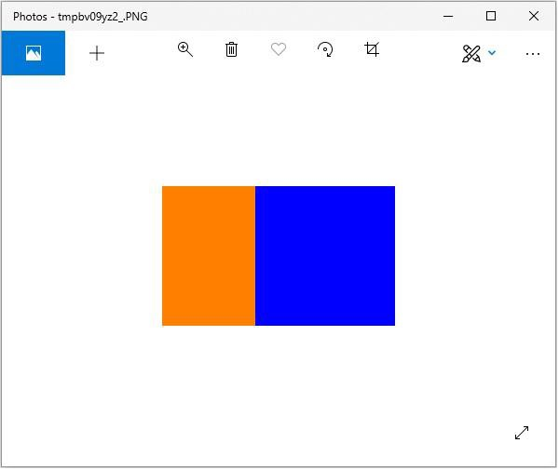

Creating greyscale images

Creating greyscale images is slightly different from creating an RGB image. We can use the 2-dimensional array to create a greyscale image.

from PIL import Image

import numpy as np

arr = np.zeros([150,300], dtype=np.uint8)

#Set grey value to black or white depending on x position

for x in range(300):

for y in range(150):

if (x % 16) // 8 == (y % 16)//8:

arr[y, x] = 0

else:

arr[y, x] = 255

img = Image.fromarray(arr)

img.show()

img.save('greyscale.jpg')

Output

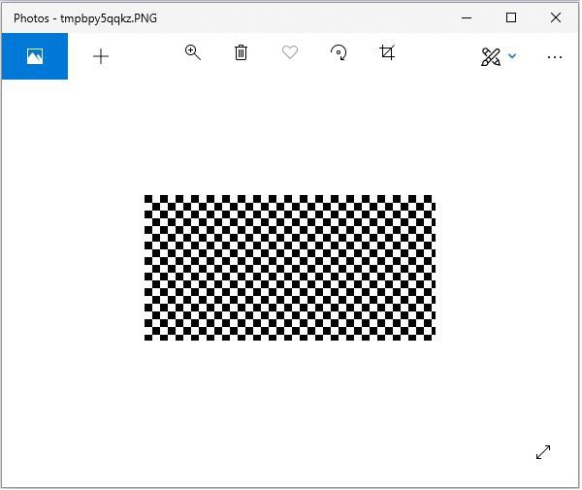

Creating numpy array from an Image

You can convert PIL image to numpy array and vice versa. A small program to demonstrate the same is stated below.

Example

#Import required libraries

from PIL import Image

from numpy import array

#Open Image & create image object

img = Image.open('beach1.jpg')

#Show actual image

img.show()

#Convert an image to numpy array

img2arr = array(img)

#Print the array

print(img2arr)

#Convert numpy array back to image

arr2im = Image.fromarray(img2arr)

#Display image

arr2im.show()

#Save the image generated from an array

arr2im.save("array2Image.jpg")

Output

If you save the above program as Example.py and execute −

* It displays the original image.
* Displays the array retrieved from it.
* Converts the array back into image and displays it.
* Since we have used show() method the images are displayed using the default PNG display utility, as follows.

[[[ 0 101 120]

[ 3 108 127]

[ 1 107 123]

...

...

[[ 38 59 60]

[ 37 58 59]

[ 36 57 58]

...

[ 74 65 60]

[ 59 48 42]

[ 66 53 47]]

[[ 40 61 62]

[ 38 59 60]

[ 37 58 59]

...

[ 75 66 61]

[ 72 61 55]

[ 61 48 42]]

[[ 40 61 62]

[ 34 55 56]

[ 38 59 60]

...

[ 82 73 68]

[ 72 61 55]

[ 63 52 46]]]

**Original Image**

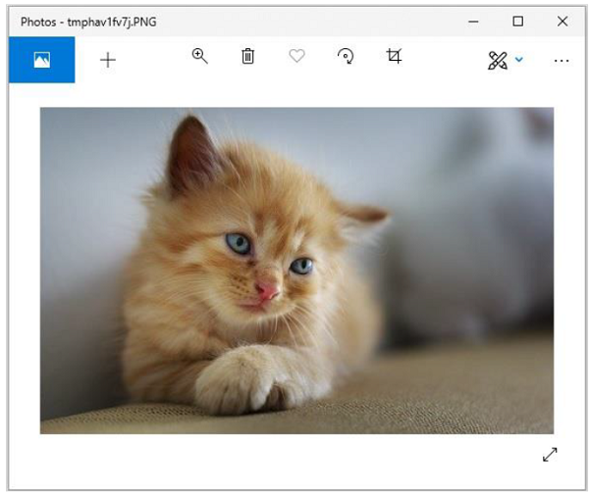

**Image constructed from the array**

